Knowledge Based Atricle

Smart Watering System

*Kacper Popis*

CMP 4267 – Computer Systems

Birmingham City University

Birmingham, United Kingdom

kacper.popis@mail.bcu.ac.uk

[https://www.researchgate.net/profile/Sudheer-Nagothu/publication/316031811_Weather_based_Smart_watering_system_using_soil_sensor_and_GSM/links/5a3a269f458515889d2bd87f/Weather-based-Smart-watering-system-using-soil-sensor-and-GSM.pdf]

*Abstract* — In this article, a prototype of a Smart Watering System will be explained, along with logic gates to give a greater understanding of the prototype. Additionally, all hardware components will be justified as to how each component works with one another to create a complete system, and potential security risks that come with the usage of listed hardware.

# Introduction

IoT, also known as Internet of Things, is a constantly evolving network of physical devices (such as sensors and vehicles) connected to the internet with the ability to interact with each another. Device communication over the internet is done via protocols, the most common being TCP / IP (Transmission Control Protocol / Internet Protocol). Alongside the introduction of more physical objects into IoT over years (like washing machines and fridges), the hardware itself has gotten more compact and simpler which allows for more possibilities of digitalisation, a major one being agriculture. With these technical developments in mind, there have been multiple benefits to digitalisation in agriculture as it can help optimise the production of crops while keeping the waste and costs as minimal as possible to reduce the negative effects on the farmers themselves and the environment. Finally, with the UN Goals in mind, this product will help in achieving zero hunger, as more healthy crops will be harvested due to their growing conditions being more appropriate and later being produced into food for consumption. Additionally, another goal that is achieved with this product is upkeeping responsible consumption and production, as growing crops utilizes a lot of water and without proper optimisation a lot of water could be wasted (such as watering crops when its raining), effectively having a negative impact on the environment.

# Literature Review

[https://easternpeak.com/blog/iot-in-agriculture-technology-use-cases-for-smart-farming-and-challenges-to-consider/]

# Methodology

This smart watering system will provide the user with necessary features to maintain efficient crop yields while staying the most cost-efficient as possible to increase profitability of the user. The proposed water system is able to utilize industry used moisture sensors and temperature sensors to collect data that will be manipulated by the master microcontroller in ways such as; sending a message to the slave microcontroller to activate a sprinkler if the value from the moisture sensor drops below a specified threshold, displaying moisture and temperature values on an LCD (liquid crystal display) screen for the consumer to see accurate measurements of the crop’s conditions. These measurements will be collected at regular set intervals (for example every 20 minutes) as this will prevent the microcontrollers from overflowing with too much data and causing delays in the system. Also, this will allow for scalability for the system itself as the consumer will be allowed to connect more data collection nodes to cover more area without causing issues for the already existing system.

The communication protocol that is used between the microcontrollers is the I2C (Inter-Integrated Circuit) protocol, the reason why this is the chosen protocol for this prototype is because the amount of data being transferred is small which won’t have a major impact on the processing speeds and won’t disrupt the communication of the two controllers. Also, with future scalability in mind, this communication protocol will be a valid choice as the same methodology can be used when upgrading to wireless by keeping multiple slave and master Arduinos functioning the same way at the cost of a potentially slower data transfer. However, if the product was to include wireless communication, then there would have to be extra security measures put into place as the data transmission would be exposed to noise that could disrupt the message or other potential ways of data being captured.

Talk about what Arduino is and its hardware

Talk about how cpu works (interactin with ram) and ALU (ALU has flipflop built in

In Figure 1 below, is a circuit depicting how each component of the system will communicate with each other to demonstrate a prototype of the final product. The circuit consists of:

* 2x Arduino Uno
* 1x LCD screen
* 1x 9v Battery
* 1x DC Motor
* 1x L239D Chip
* 1x Soil Moisture Sensor
* 1x Temperature Sensor
* x Wires

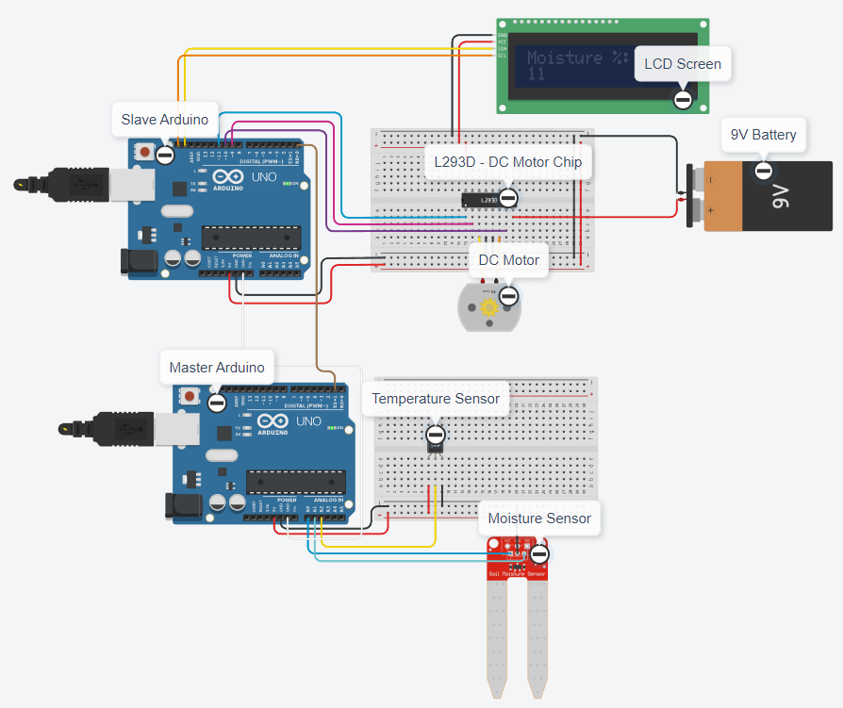

Figure

## Implementation of a Moisture Sensor

Moisture Sensors use dielectric-permittivity to calculate the volumetric content of water in soil [1] to change the resistance value of the sensor, this resistance value is then constantly communicated to the connected micro-controller. The resistance of the Moisture Sensor decreases as more water is present in the soil and increases when less water is present. These sensors will be connected in groups of other moisture sensors and transmit all their data towards their corresponding master node. This connection can be changed from wired to wireless as running cables through large plots will end up harming the environment itself because cables could break down due to the conditions outside resulting in cable replacements or possibly endangering the crops.

[<https://gi.copernicus.org/articles/12/45/2023/gi-12-45-2023.pdf>]

[1 - https://www.researchgate.net/profile/Sudheer-Nagothu/publication/316031811_Weather_based_Smart_watering_system_using_soil_sensor_and_GSM/links/5a3a269f458515889d2bd87f/Weather-based-Smart-watering-system-using-soil-sensor-and-GSM.pdf]

[https://lastminuteengineers.com/soil-moisture-sensor-arduino-tutorial/]

## Implementation of a Temperature Sensor

Temperature sensors are working alongside moisture sensors. These sensors will be feeding information towards the master node at similar intervals to the moisture sensors and the data collected from these sensors will be displayed to the user on an LCD screen. When placed in plots of land, these temperature sensors will be connected near the moisture sensors (not in the soil itself) to gather more accurate data of the crop conditions.

## Implementation of an LCD Screen

LCD Screens will be displaying data gathered from the moisture and temperature sensors to the user, the information that is to be displayed will be sent from the master Arduino directly to slave Arduino, which will then display the data on the LCD screen. The data on the LCD screen updates every time the slave Arduino will receive data from the master Arduino. The aim of this LCD screen will be to display moisture and temperature measurements simultaneously of each group of sensors, and allow the user to cycle through different groups to see their conditions. Also, the user will have a message displayed to them when crops will soon be watered.

Using the data collected from both moisture sensors and temperature sensors, the micro-controllers will be able to control an irrigation system (for example a network of sprinklers) to determine when water should be spraying crops to keep them at their most optimal growth conditions. The microcontroller in charge of the irrigation system will receive a command when to water plants and when to stop from the microcontroller handling the sensors’ data. The threshold for activation of sprinklers will have a default value set in the slave Arduino and when the moisture reaches that specified threshold the irrigation system that the controller is connected to will activate (in Figure 1, the DC motor is in charge of the irrigation system to run when crops will need to be watered, and stop when watering needs to stop) and water the crops for a fixed amount of time - 20 / 30 minutes. An alternative solution to the irrigation system is instead of watering the crops for a fixed amount of time, the crops could be watered until a specific amount of moisture is in the soil, for example watering starts when moisture reaches 40% and finishes when moisture reaches 80%.

However, there are multiple aspects when it comes to farming that will need to be accounted for to make this product more efficient and adaptive to different farmer’s needs, such as different soil types and different crops. Through this, the product will not be limited to only a specific group of farmers, but rather inclusive to all which will bring in more customers for the company. To actually make this product be more flexible, there will be different modes developed that the user will be able to cycle through using buttons, for example vegetation mode would provide a moisture range of 41% - 60% meanwhile trees/shrubs would have a moisture range of 21% - 40% as research shows that “the optimal range of soil moisture for crops depends on the specified plant species, but the range for most crops is between 20% - 60%” [2]. The user will also be able to have a custom mode where they will be able to set the moisture range themselves to

[2-https://eos.com/blog/soil-moisture]

[3-https://www.acurite.com/blog/soil-moisture-guide-for-plants-and-vegetables.html#:~:text=Recommended%20Soil%20Moisture%20Levels&text=It%20is%20important%20to%20note,between%2041%25%20%2D%2080%25.]

# Results

Remove all unnecessary sections and replace with your content: This template, modified in MS Word 2007 uses time new roman font, size 10

# Discussion

Remove all unnecessary sections and replace with your content: This template, modified in MS Word 2007 uses time new roman font, size 10

# Conclusion

Remove all unnecessary sections and replace with your content: This template, modified in MS Word 2007 uses time new roman font, size 10

##### References

Use Harvard Referencing

Eason G, Noble N, and Sneddon N.I, (1995) “On certain integrals of Lipschitz-Hankel type involving products of Bessel functions,” Phil. Trans. Roy. Soc. London